Mechanical Properties of Aluminum/Alumina
Mixture by Process of Cold Spray

Prepared by:
Ashleigh Giffen and Myriah Santistevan

Faculty Advisors:
Dr. Michael West
REU Site Director, Department of Materials and Metallurgical Engineering

Dr. Bharat Jasthi
Research Scientist II, Advanced Materials Processing and Joining Laboratory (AMP)

Dr. Alfred Boysen
Professor, Department of Humanities

Program Information:
National Science Foundation
Grant NSF #0852057

Research Experience for Undergraduates
Summer 2011

South Dakota School of Mines and Technology
501 East Saint Joseph Street
Rapid City, SD 57701

TABLE OF CONTENTS
Abstract ……………………………………………………………………………
Objectives …………………………………………………………………….
Findings ………………………………………………………………………
Introduction ……………………………………………………………………….
Background ……………………………………………………………………
Objectives …………………………………………………………………….
Developmental Plan …………………………………………………………….
Broader Impact ……………………………………………………………………
Procedure ………………………………………………………………………….
Materials ……………………………………………………………………... Equipment …………………………………………………………………….
Procedures …………………………………………………………………….
Results …………………………………………………………………………….
Microstructure …………………………………………………………………...
Microhardness…………….……………………………………………………...
Discussion …………………………………………………………………………
Conclusion ………………………………………………………………………...
Summary ……………………………………………………………………...
Recommendations ………………………………………………………………
Future Work …………………………………………………………………...
References ………………………………………………………………………...
Acknowledgments ………………………………………………………………...

Abstract
Cold Spray technology has been used in repairs and strengthening of surfaces of various metals and metal alloys, but little is known about the mechanical properties of the deposits made to repair these objects. This research is being conducted to find out if using Cold Spray as repair substance, will it have similar properties/behaviors as the metal it is filling in. In this report the authors will test the mechanical properties of Cold Sprayed aluminum and alumina mixtures. This research will result in the knowledge of what mixtures of aluminum and alumina have a higher tensile strength and the most ideal mechanical properties. Some findings that have been made in this research have been that a mixture of aluminum 2024 and silicon carbide requires a high pressure system which is unavailable at this time. We also have found in our microhardness testing, the strongest points of the deposit are the center and the edges of the deposit. The weaker part of the deposit lies in the high point of the deposit. Refer to Figure # in “Results” section.
- Introduction
Cold Gas-Dynamic Spraying (Figure 1), also known simply as Cold Spray, was developed in the mid-1980s by Dr. Anatolii Papyrin at the Institute of Theoretical and Applied Mechanics of the Russian Academy of Science in Novosibirsk, Russia. Since its development, Cold Spray has been used with a wide variety of metal and ceramic mixtures to strengthen and repair a wide variety of objects. Erik Klinckman is currently working on looking at the coefficient of thermal expansion of aluminum/alumina mixed metal composites and whether they follow a rule of mixtures. The focus of the authors’ research is to test the mechanical properties of Erik Klinckman’s deposits as sprayed, heat treated and compare them to his deposits that have been friction stir processed. We will be using the multiple mixtures that have been sprayed by Erik Klinckman and testing these sprays to determine which mixture and parameters give the best mechanical properties.
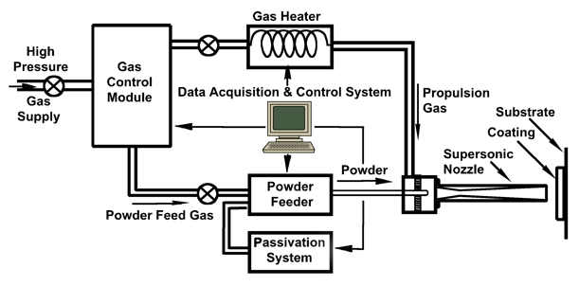

Figure 1 – Cold Spray System
- Broader Impact
In studying the mechanical properties of Cold Sprayed aluminum alumina mixture, we will have a better understanding of the stress and strain a coating of this mixture can withstand. In doing this we will be able to make more efficient coatings on surfaces of a wide variety of metals to make better repairs on cracked or broken pieces or even in the manufacturing of different metals to increase their wear resistance and corrosion resistance.

- Procedure
3.1 Materials
Aluminum/alumina powder provided to us by the AMP Center
Cold Spray Deposits courtesy of Erik Klinckman and teammates Nathan Salden, and Owen Britton
Cast Iron Dog-Bone Mold provided to us by Matthew Carriker
3.2 Equipment
Cold Spray Equipment
MTS Tensile Machine
Vickers Microhardness Machine
Optical Microscope
3.3 Procedures
The initial research that took place was to test the mechanical properties of aluminum 2024 and silicon carbide mixture that had been deposited by process of Cold Spray. We sifted the aluminum powder to 64 – 105 grit, combined with silicon carbide and attempted to spray the mixtures of 20% SiC by weight, 30%, and 40%. We were unable to obtain a thick deposit due to the fact of this particular mixture needs a high pressure Cold Spray system and we only have access to a low pressure system at this time. After this attempt we, the authors, decided to collaborate with Erik Klinckman, who had been making successful thick deposits for his study of the thermal expansion of the Cold Spray deposit.
Mr. Klinckman provided the authors with two thick deposits, one with 90% alumina 10% aluminum ratio by weight and the other with a 50/50 ratio by weight. We mounted these two pieces to evaluate the microstructure of the two specimens. While evaluating the microstructure we found that the weight ratio is not the same as the volume ratio. When given a 50/50 mixture only about 25% of the deposit is alumina and the rest is aluminum. When given a 10/90 mixture, it appears to be more of a 50/50 mixture when deposited. The 10/90 microstructure is ideal for strength but not ideal for spraying. Further research on the volume ratio compared to weight ratio will be conducted later on. The authors decided to pursue the properties of the 50/50 mixture due to the ease of spraying.

Figure 2 10% Aluminum 90% Alumina Figure 3 50% Aluminum 50% Alumina
A dog bone mold courtesy of Matthew Carriker has been provided to Erik Klinckman. The purpose of this dog bone is to make a deposition and evaluate the tensile properties of an aluminum alumina deposit. The initial mold was an unsuccessful design. The dimension of the dog bone is 2” long by 1” wide and a ¼” deep, and was cut into two pieces, down the middle. As you can see in Figure 4, the mold had been milled with a 3/8” end mill which produces straight walls around the perimeter of the mold. The thick solid bottom also hindered the ability for the deposit to be removed. While this dog bone had been created, Mr. Klinckman made a thick deposition of 50/50 aluminum alumina onto a substrate of stainless steel foil. This deposit was easily removed from the foil. This result helped in redesigning the dog bone mold. As you can see in Figure 5, this new mold was milled using a 0.200” ball nose end mill; which creates a rounded perimeter, and an open top and bottom was added to the design. The dimension of the second dog bone is 2” long, ¾” wide, and ¼” deep. This design is made to set upon a stainless steel foil substrate and make for a solid piece of Cold Spray deposited aluminum-alumina. A deposit has yet to be made in this mold.
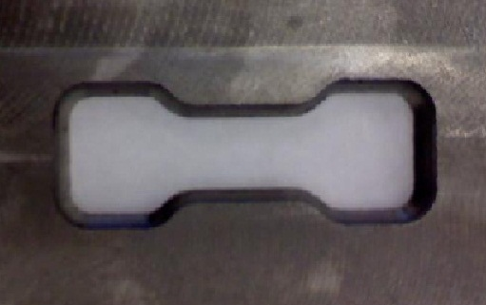
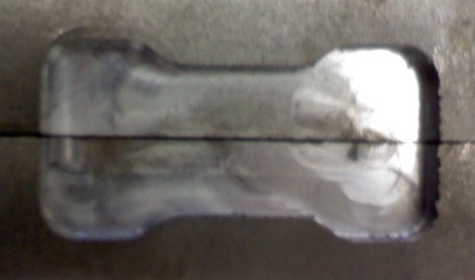

Figure 4 - Dog Bone #1 Figure 5 - Dog Bone #2
The authors were provided with a Cold Spray deposition of 50/50 aluminum alumina that had been sprayed onto a stainless steel foil substrate. We removed the deposit from the substrate with careful pealing techniques. The specimen was cut into quarters with a dermal tool, and then with a wet saw a small piece of deposit was cut off each of the quarters which were mounted for microstructural evaluation and microhardness testing.
- Results
The deposit made into the original dog bone mold split into two pieces upon attempting to remove the deposit from the mold. When attempting to remove the deposit from the mold, the deposit crumbled and broke apart which did not allow us to anneal one of the pieces. We have since redesigned the dog bone mold but no results have come of it as of yet. Fortunately, Mr. Klinckman made a square deposit onto stainless steel foil substrate which we were successfully able to remove from the foil.
The deposit removed from the stainless steel foil substrate was a 50/50 aluminum-alumina deposit. The deposit was cut into quarters with a dermal tool, and then with a wet saw a small piece of deposit was cut off each of the quarters were mounted and polished to evaluate the microstructure and perform microhardness testing on the deposit. We applied 300g of force in our microhardness test. We evaluated a solid piece of deposit with virtually no cracks or imperfections in the deposit and another piece of deposit which had a fracture and the results were quite interesting. The solid piece proved to be strongest in the center of the deposit and in the outer section of the deposit that slopes at an angle. The weakest point was at the section that peaks when looking at the deposit from the side. (See Figure #) The data we acquired on the cracked sample showed that one side of the crack had a high microhardness and the opposite side had a significantly low microhardness. We will be investigating to see whether the difference in strength was the cause of the fracture. The data we obtained can be viewed in the Vickers Microhardness test and results below.
Dwell Time |  | Force | .05in Travel distance between each mark
15 seconds |  | 300g
Vickers Microhardness
No Defects |  |  |  |  | Figure 6 - Thick Deposit No Apparent Fractures
Sample 1 | DATA |  | Description |  | 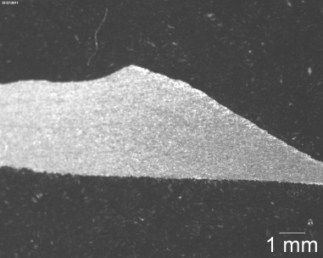
1 | 51.4 |  | center
2 | 51.4 |  | near a high point
3 | 47.1 |  | near a high point
4 | 47.5 |  | near a high point
5 | 46.7 |  | close to the outside of the sample
6 | 60.4 |  | Al2O3 on the edge of the diamond
7 | 66.5 |  | even amount particle of Al2O3 were smaller
8 | 61.0 |  | Al2O3 center of diamond
9 | 63.9 |  | on the edge
 | Average | 55.1 Hv (300g) | Table 1

Graph 1

Sample 2 | DATA | Description  Figure 7 - Thick Deposit with Fracture
1 | 62.8 | Towards the bottom, thin part of the deposit
2 | 55.0 | 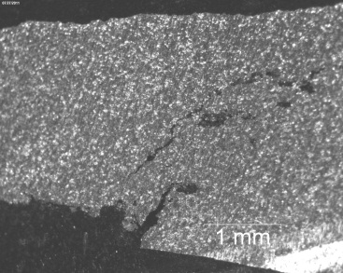
3 | 57.5 | Thicker part of the deposit
4 | 54.7 | near a crack
5 | 61.3 | next to the crack
6 | 38.4 | right next to the crack
7 | 59.8 | other side of the crack
8 | 66.8 | Thicker part of the deposit
9 | 64.9 | Thicker part of the deposit
10 | 42.0 | Thickest part of the deposit
11 | 52.8 | Thicker part of the deposit
Average | 56.0 Hv (300g) | Table 2

Graph 2
Graph 2
5. Discussion
After microhardness testing of the two samples we can see that the microhardness is relatively close for the two materials. The average was 56.0 Hv(300g) (cracked) and 55.1 Hv(300g) (not cracked). For pure aluminum its Vickers Hardness is 17.0 Hv and alumina is around 1800-2000 Hv (500g). The microhardness testing that was done on deposit shows that the strength is greater than aluminum but significantly weaker than the alumina. Since there isn’t much information about deposit’s mechanical properties, we are going to compare the deposits to the solid state metals. One of most interesting parts of the microhardness testing was near were the crack lays in the cracked sample. In the cracked sample, we microhardness tested it and near the crack two different readings were produced. On one side of the crack the Vickers Hardness read 38.4 Hv (300g) (Table 2) and then on the other side it read 59.8 Hv (300g) (Table 2), as of right now we are unaware of the reason behind the different readings but that will be looked at later on.
Also we found that closer to the middle of the sample the stronger it is, but near high peaks the strength starts to decrease slightly and this was true for both samples. Part of the reason why the peaks could have been weak was because the deposit wasn’t sprayed in between every few sprays. Machining after every few sprays allows for a flat surface for the powder to deposit on; which is best when spraying a good deposition. Looking at Table 1 the other strong point was near a piece of alumina. This makes sense because the Vickers Hardness Test of alumina is 1800-2000 Hv (500g), which suggests the parts of the deposit with more alumina would have a higher microhardness.

- Conclusion
  - Summary
A thick deposit of aluminum alumina 50/50 weight ratio was deposited on a stainless steel foil. That deposition was then peeled off of the foil and cut into pieces to be mounted. After being mounted, ground, and polished the microstructure was looked at and was determined that more testing needs to be done to find out how the weight ratio compares to the volume ratio.
Microhardness was then preformed on two of the mounted pieces: one cracked and one with no defects or cracks. The Vickers Hardness Test was done and the average hardness was 56.0 Hv (300g) on the cracked piece and 55.1 Hv (300g) on the non-cracked piece.
  - Future Work
When looking at the microhardness of the two deposits we can see that the deposits are strong but still brittle. To increase its mechanical strength we are going to anneal the deposits and conduct another microhardness test to see how much the annealing helps.
The next step in the process is to use the newly designed dog bone mold to produce a useable dog bones for tensile testing. Half of them should be annealed and half not so then they can be compared. Depending on how well the second dog bone mold works (Figure 5), another dog bone mold needs to be made at a standard set of dimensions.
One important test that should be done is to convert the weight ratio to the volume ratio. This is important because it would produce the exact ratio of aluminum to alumina. Also, examination of the microstructure is a necessity because that will show how the grains lay together in a thick deposit. This would be good to know so that the best mixture can be used for different repairs.
After some basic tests are done, the thick deposits should be Friction Stir Processed to see how Friction Stir increases the mechanical properties. The microhardness tests and the tensile tests will need to be done on these samples too. The microstructure will need to be examined to see how the grains lay together.

Acknowledgements
The funding for this research came from the National Science Foundation Grant #0852057. Thanks to advisors Dr. Bharat Jasthi and REU site director Dr. Michael West for their direction and advice, Professor of English Dr. Alfred Boysen for his guidance in writing and speaking, and a special thanks to all of the faculty and staff at SDSM&T and the students working in the Advanced Material Processing Center for their help.

References
- Papyrin, Anatolii. (2007). Cold Spray Technology: Elsevier.
- Rech, Silvano, Trentin, Andrea, Vezzu, Simone, Legoux, Jean-Gabriel, Irissou, Eric, & Guagliano, Mario. (2010). Influence of Pre-Heated Al 6061 Substrate Temperature on the Residual Stresses of Multipass Al Coatings Deposited by Cold Spray. Journal of Thermal Spray Technology, 20(1-2), 9.
- Wang, Qiang, Birbilis, Nick, & Zhang, Ming-Xing. (2011). Interfacial structure between particles in an aluminum deposit produced by cold spray. Material Letters, 65(11), 3.

